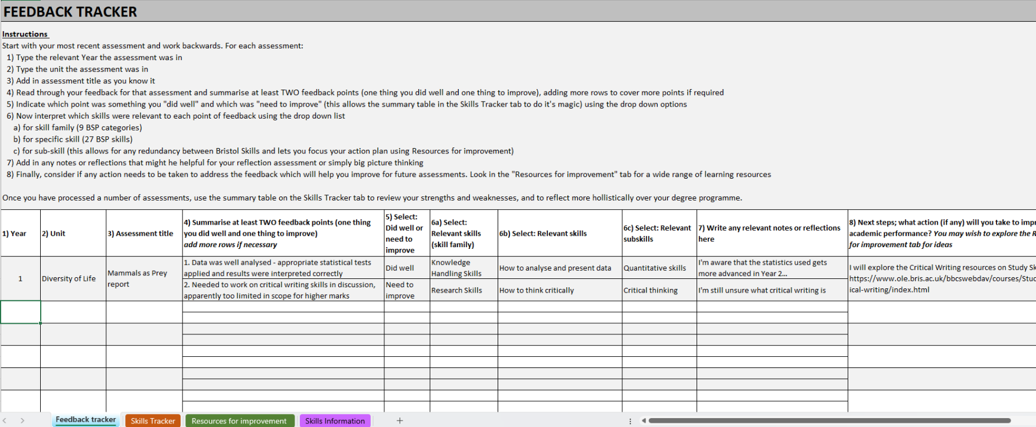
Feedback Engagement Tool (FET) user guide
This is what you will see upon opening the file

The excel file has four tabs to help you take apart and keep track of all your feedback:
- Feedback tracker tab is there for you to log all the past feedback received, action plan, and review your feedback categorically before starting a new piece of assessment.
- Skills Tracker tab provides an overview of which skills you are doing well or need to improve according to the feedback summary you provided, as well as instructions for completing the skills assessment in My Skills, and space for you to reflect on your progress each teaching block.
- Resources for improvement tab presents links and resources you can use to help you improve skills mentioned in your feedback and to feedforward in future assessments.
- Skills info tab contains definition of the Bristol Skills Profile and subsequent sub-skills, this can be used as reference when taking apart and logging your feedback.

Instructions for using the Feedback tracker tab
Click on the Feedback tracker tab
An example is provided in the first line of the spreadsheet. Use this to guide you for inputting your own feedback. You can delete the example afterwards. If you require more in-depth instructions please see below.
Start with your most recent assessment and work backwards. For each assessment:
- Type the relevant Year the assessment was in

- Type the unit/module the assessment was in

- Add in assessment title as you know it

- Read through your feedback for that assessment and summarise at least TWO feedback points (one thing you did well and one thing to improve), adding more rows to cover more points if required

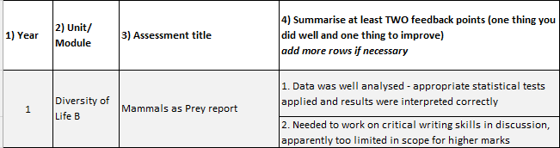

To add in new rows:
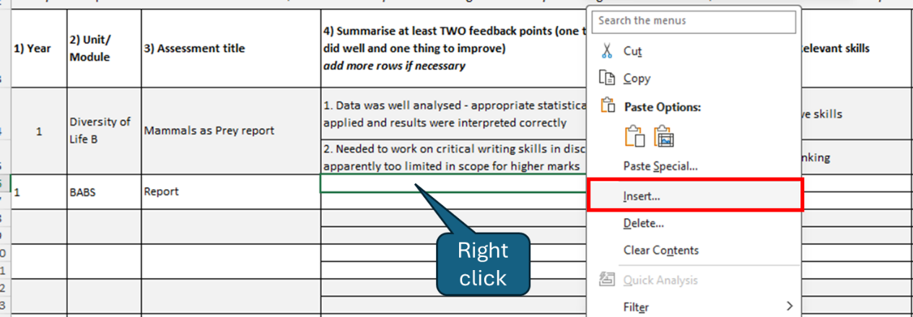
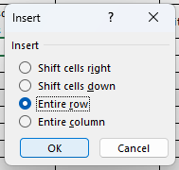

Add in new rows by right clicking the cell highlighted in the picture, select “Insert”, then select “Entire row” and click OK.

- Indicate which point was something you "did well" and which was "need to improve" (this allows the summary table in the Skills Tracker tab to do it's magic) using the drop down options
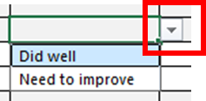
Select the next available cell, click on the arrow highlighted in RED to bring up drop down list.

- Select the relevant skills

  - Now interpret which skills were relevant to each point of feedback using the drop-down list and select the most relevant skill from the 9 BSP skill families.
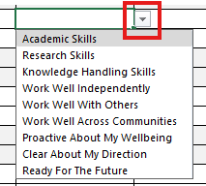

  - Select the relevant BSP skill from the drop-down list

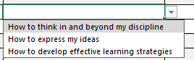

  - Now choose the relevant topic area that best relates to your feedback. These are generic sub-skills that ensure you get to the resources you need. To see how the sub-skills relate to each BSP skill, explore the “Skills Information” tab.
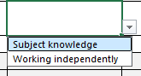

- Add in any notes or reflections that you have about the assessment

- Finally, consider if any action needs to be taken to address the feedback which will help you improve for future assessments. Look in the "Resources for improvement" tab for a wide range of learning resources.
Instructions for using the Skills Tracker tab
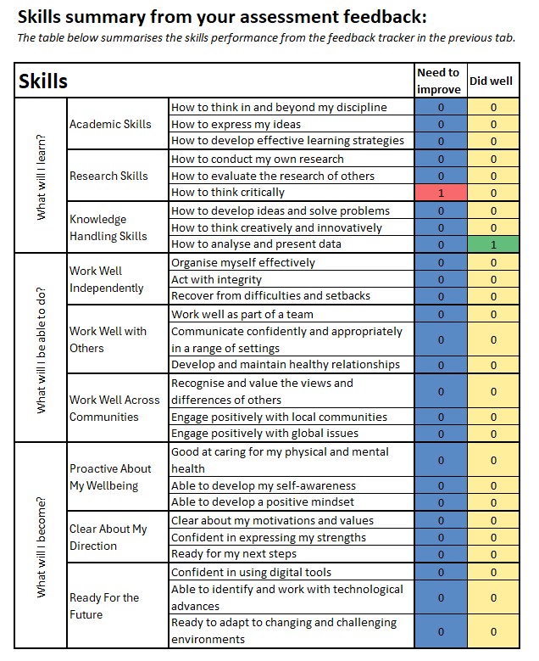
ck
Click on the Skills Tracker tab
This tab is in two parts. The first part is a skills summary from your assessment feedback, so you can keep track of which skills you are doing well in and which skills you get notes for improvement.
Track where you need to improve
- The table on the left is automatically updated to keep a tally of the number of times a skill is coupled with the feedback you logged
Note: if this is not updated, please check you have selected the skills involved (column G) correctly.

- Use the table to help you decide your priorities
  - If the number is high/shown as red on the “Need to improve” column, the skill has been mentioned and identified for improvement in multiple feedback. You may wish to put more emphasis on improving that skill.
  - Likewise, if a number is high on “Did well”, you are doing a good job of demonstrating that skill in your assessments. Keep it up and check you have continued to do so in your next assessment!

The second part of this tab contains instructions to complete a skills assessment test in My Skills. You should aim to complete this every teaching block to keep track of your progress in developing your Bristol Skills Profile.
Use the space provided to reflect on how you are doing in your academic assessments and your general academic development. You do not need to share this information with anyone unless you wish to, and you can choose to reflect on any aspect of your practice, from how you are feeling that teaching block to what your academic priorities are, or what your career ambitions might be.
Don’t forget to log your skills in the Skills Log in My Skills to keep track of any actions taken.

Instructions for using the Resources for improvement tab
- Click on Resources for improvement tab
- Use the drop-down arrows to select the skill you are looking for resources on. Simply click on the arrow and start typing the skill you wish to view resources for in the box highlighted, then click OK.
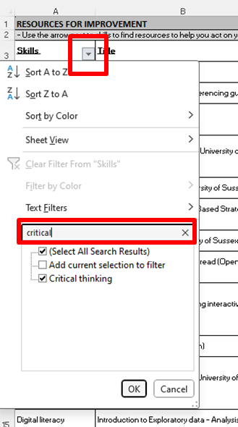

You can filter by skills and by type of resources.

Don’t forget to log your skills in the Skills Log in My Skills to keep track of any of the resources that you’ve used.

